
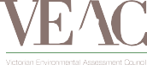


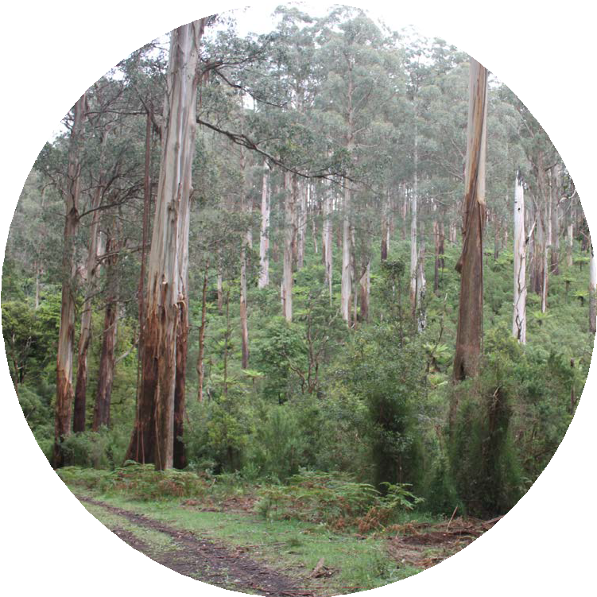
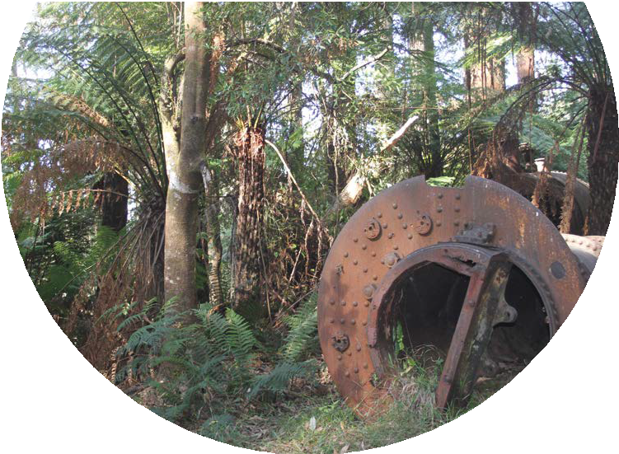
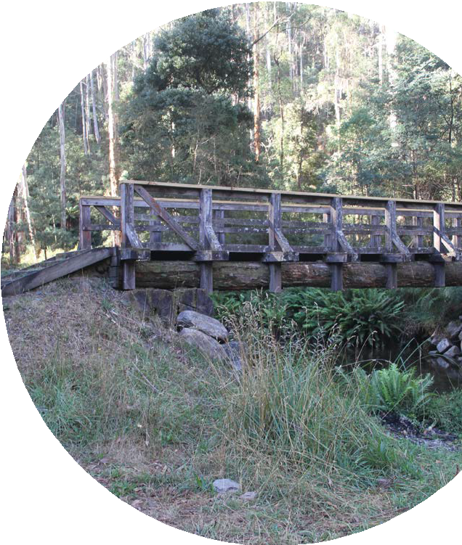
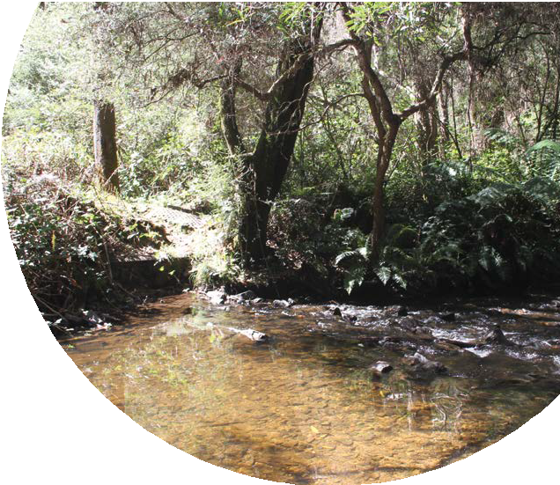

2023 / 2024

Victorian Environmental Assessment Council
ANNUAL REPORT

Steve Dimopoulos MP Minister for Environment 8 Nicholson St
East Melbourne VIC 3002

Dear Minister
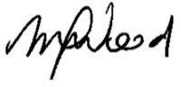
In accordance with the requirements of Section 14(1) of the Victorian Environmental Assessment Council Act 2001, the Victorian Environmental Assessment Council is pleased to submit to you its twenty-second Annual Report, covering our activities for the period 1 July 2023 to 30 June 2024.

Mellissa Wood Chairperson
Victorian Environmental Assessment Council 30 September 2024

© State of Victoria, Victorian Environmental Assessment Council 2024.

This work is licensed under a Creative Commons Attribution 4.0 International licence. You are free to re-use the work under that licence, on the condition that you credit the State of Victoria as author. The licence does not apply to any images, photographs or branding, including the Victorian Coat of Arms, the Victorian Government logo and the VEAC logo. To view a copy of this licence, visit https://creativecommons.org/ licenses/ ISSN: 2207-0613 Online/PDF

Accessibility
If you would like to receive this publication in an alternative format, please telephone VEAC on 1800 134 803,
email: veac@deeca.vic.gov.au. This document is also available on the internet at www.veac.vic.gov.au

Disclaimer
This publication may be of assistance to you but the State of Victoria and its employees do not guarantee that this publication is without flaw of any kind or is wholly appropriate for your particular purposes and therefore disclaims all liability for any error, loss or other consequence which may arise from your relying on any information in this publication.

CONTENTS PAGE
ACKNOWLEDGMENT OF COUNTRY 2
CHAIRPERSON’S FOREWORD 3
VICTORIAN ENVIRONMENTAL ASSESSMENT COUNCIL 4
INVESTIGATIONS 8
ASSESSMENTS AND ADVICE 8
- ASSESSMENT OF THE VALUES OF STATE FORESTS
IN THE CENTRAL HIGHLANDS 8
- ASSESSMENT OF EARLY GOVERNMENT- ACCEPTED
LCC RECOMMENDATIONS – SUPPLEMENTARY REPORT 11
DATA AND INFORMATION MANAGEMENT 11
BILL BORTHWICK STUDENT SCHOLARSHIPS 2024 12
COMMITTEES 13
MEMBERSHIP OF EXTERNAL COMMITTEES 13
CONSULTANCIES 13
OPERATIONAL GOVERNANCE 13

ACKNOWLEDGMENT OF COUNTRY
We acknowledge and respect Victorian Traditional Owners as the original custodians of Victoria’s land and waters, their unique ability to care for Country and deep spiritual connection to it. We honour Elders past and present whose knowledge and wisdom has ensured the continuation of culture and traditional practices. We are committed to genuinely partner, and meaningfully engage, with Victoria’s Traditional Owners and Aboriginal communities to support the protection of Country, the maintenance of spiritual and cultural practices and their broader aspirations in the 21st century and beyond.

CHAIRPERSON’S FOREWORD

I am pleased to present the 2023-24 annual report of the Victorian Environmental Assessment Council (VEAC) to the Minister for Environment, Steve Dimopoulos MP, in accordance with the Victorian Environmental Assessment Council Act 2001.
This year marked significant changes for VEAC. We bade farewell to our longest-serving Executive Officer, Joan Phillips, after 17 years of dedicated service, and welcomed Louise Persse as acting Executive Officer. Joan supported VEAC with integrity and expertise and the Councils under her watch have greatly appreciated the experience, management and corporate knowledge she provided. We also farewelled Council members Joanne Duncan, Anna Kilborn, and Nick Wimbush, thanking them for their valued contributions, while welcoming Dave Kendal and Jennifer Wolcott, who bring diverse skills and experiences to Council.
VEAC continued to advance new partnerships and ways of working across the conservation and use of Victoria’s public lands. We collaborated with Department of Energy, Environment and Climate Action (DEECA) on identifying the future needs of Victoria’s biodiversity and protected area system. We are pleased to be now part of processes that are prioritising ‘braiding’ scientific and Traditional Owner knowledge systems and adequately respecting the rights of Traditional Owners. Importantly, we are working with Traditional Owners to redefine active management to acknowledge human-landscape interdependence as fundamental to environmental stewardship and Caring for Country.
A key achievement was the completion of the “Assessment of the values of state forests in the Central Highlands, Interim Report”. This comprehensive scientific assessment will inform the Eminent Panel for Community Engagement (the Panel) recommendations on the future uses of Central Highlands state forests. The report revealed the exceptional ecological, cultural, and socio-economic significance of these forests, which are home to nearly 400 threatened species and the world’s tallest flowering plants. It highlighted their crucial role in water security, carbon storage, and biodiversity conservation, as well as their substantial recreational, scientific, heritage and biocultural value.
Looking ahead, VEAC will complete an assessment of the economic implications of the Panel’s recommendations for the Central Highlands state forests and provide scientific value assessments to support the work of the Great Outdoors Taskforce on the future use and management of the eastern Victorian forests.
We also continued our support for emerging environmental leaders through the Bill Borthwick Scholarship program which is funding five scholars in 2024.
I extend my gratitude to the state government departments and agencies, Traditional Owners, local governments, scientific community, community groups and organisations, and members of the public for their assistance and support. Special thanks go to VEAC’s expert staff for their dedication during this transitional year, and to DEECA for their invaluable support.
As we look to the future, VEAC remains committed to providing evidence-based advice on the protection and sustainable management of Victoria’s environment and natural resources. We will continue to adapt our approaches to assessing the multiple values of our ecosystems, support First Nations’ rights to self- determination, and strive for outcomes that benefit both nature and communities.

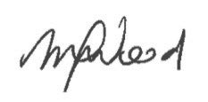
Mellissa Wood
Chairperson, Victorian Environmental Assessment Council

VICTORIAN ENVIRONMENTAL ASSESSMENT COUNCIL

OUR PURPOSE
VEAC was established under the Victorian Environmental Assessment Council Act 2001 (the VEAC Act) to provide independent and strategic advice to the Victorian Government on matters relating to the protection and ecologically sustainable management of the environment and natural resources of Victoria’s public land (refer to Sections 4 and 5 of the VEAC Act).

OUR VALUES
Our organisational values reflect our attitude to the public land estate, the community and the environment.
- We think long term.
- We use evidence and expertise as the foundation of our work.
- We act conscientiously in the public interest.
- We seek out and listen to diverse voices.
- We treat everyone with respect.
- We work independently and are accountable for our activities.

OUR FUNCTIONS
VEAC:
- carries out investigations and assessments and provides advice as requested by the Minister on matters relating to the protection and ecologically sustainable management of the environment and natural resources of public land
- carries out any other functions conferred by the VEAC Act or any other Act (refer to Section 6 of the VEAC Act).
In carrying out investigations and making recommendations VEAC is required to have regard to:
- the principles of ecologically sustainable development
- the need to conserve and protect biological diversity
- the need to conserve and protect any areas which have ecological, natural, landscape or cultural interest or significance, recreational value or geological or geomorphological significance
- the need to provide for the creation and preservation of a comprehensive, adequate and representative system of parks and reserves within the State of Victoria
- the existence of any international treaty ratified by the Commonwealth of Australia which is relevant to the investigation
- any agreement at a national, inter-state or local government level into which the Government of Victoria has entered, or under which the Government of Victoria has undertaken any obligation in conjunction with the Commonwealth, a state, territory or municipal council, which relates to the subject matter of the investigation
- the potential environmental, social and economic consequences of implementing the proposed recommendations
- any existing or proposed use of the environment or natural resources.
Powers held by VEAC include the ability to appoint committees and, with the consent of the relevant Minister, make use of the services of any person employed in DEECA (refer to Section 7 of the VEAC Act).
A website containing general information about VEAC’s role, operation and current and past investigations and assessments is available at www.veac.vic.gov.au. The site also contains links to past investigations and studies conducted by the Environment Conservation Council (ECC) and the Land Conservation Council (LCC).

COUNCIL MEMBERSHIP

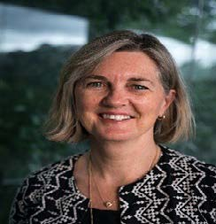
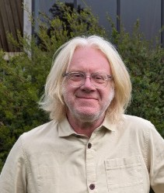



(L-R) Mellissa Wood, Dave Kendal, Nicola Ward, Nick Wimbush Jennifer Wolcott.
VEAC members are appointed under the VEAC Act. Members from 1 July to 6 July 2023 were Joanne Duncan and Anna Kilborn. Members from 7 July 2023 to 30 June 2024 were Dave Kendal and Jennifer Wolcott. Members for the period 1 July 2023 to 30 June 2024 were Mellissa Wood (Chairperson) and Nicola Ward. Nick Wimbush was a member from 1 July 2023 and wrote to the Governor in Council on 15 February 2024 to tender his resignation from VEAC. It was formally accepted by the Governor in Council on 28 May 2024.

Mellissa Wood (Chairperson)
Mellissa Wood brings over 30 years of expertise in scientific and policy leadership within international development, conservation, environmental management, and sustainable food systems. Her career spans executive roles with the Australian Government, as well as prominent international organisations, including the UN Food and Agriculture Organisation (FAO) and CGIAR.
Mellissa has served as General Manager of the Australian Centre for International Agricultural Research (ACIAR) and was a key member of CGIAR’s System Council and System Management Board. Her extensive international experience encompasses Sub-Saharan Africa, Southeast Asia, and the Pacific. Notably, she was the Director of the Australian International Food Security Centre in Eastern and Southern Africa and worked at FAO in Rome as Director of Programs, at the Global Crop Diversity Trust.
Additionally, she spent 15 years at the Bureau of Rural Sciences within the Federal Department of Agriculture, Forestry and Fisheries, where she provided critical scientific advice for natural resource management.
Currently, Mellissa is a member of the Eminent Panel for Community Engagement and The Great Outdoors Taskforce, and she serves as a Visiting Scientist at CSIRO. She holds a Master of Public Policy from Crawford School, Australian National University, a Bachelor of Science in Resource and Environmental Management from Australian National University and is a graduate of the Australian Institute of Company Directors and a member of the Royal Society of Victoria.

Dave Kendal
Dr Dave Kendal is an internationally recognised expert on urban nature and ecology, biodiversity conservation, social values for the environment and public perceptions of nature. He is Director of Future in Nature Pty Ltd which provides consulting advice on urban nature, social values and conservation, after researching and teaching about the reciprocal effects of people on nature in cities and beyond for 20 years. He has worked at the Australian Research Centre for Urban Ecology, a division of the Royal Botanic Gardens Melbourne, and at the University of Melbourne, and the University of Tasmania. Dave has been a key contributor to many policies and programs that have improved social-ecological systems in Australia and around the world, including the City of Melbourne’s urban forest strategy and precinct planning process, the global Climate Change Alliance of Botanic Gardens Climate Assessment Tool, the NSF funded Nature-based Solutions for Urban Resilience in the Anthropocene (NATURA) network, the City of Auckland’s urban ngahere strategy, Australia’s National Environmental Science Program, Melbourne Water and DELWP community values assessments. He has held expert advisory roles under Australia’s EPBC Act, for the European Commission, the Technical University of Munich, BGANZ and the Living Melbourne Strategy. He was a member of Australia’s Threatened Species Scientific Committee from 2015-2019.

Nicola Ward
Nicola Ward has held senior positions in the state governments of New South Wales and Victoria and local government, with extensive public policy experience in environment and natural resource management. She has policy and program expertise in environment, sustainability and climate change; strategic planning, land use and development; community infrastructure planning; sport, recreation and open space planning. She is experienced in organisation strategy, business transformation and risk and performance.
She holds a range of volunteer positions including Board Director of the Natural Resources Conservation League (Vic), Independent Chair of the Southern Brown Bandicoot Regional Recovery Group and committee member of various community groups. She was previously a Sessional Member of Planning Panels Victoria and Board Director of the Port Phillip and Western Port Catchment Management Authority. Nicola has a Masters degree in Social Science (Environment and Planning) with Distinction and an Honours degree in Social Science. Nicola is a member of the Australian Institute of Company Directors.

Nick Wimbush
Nick Wimbush is a Member at the Victorian Civil and Administrative Tribunal.
He has strong public sector governance experience in senior roles with a focus on environmental planning and climate change. He is a highly experienced chairperson who has presided over many significant public inquiries with high levels of public interest. He holds a Master of Laws (Juris Doctor) from Monash University; a Bachelor of Science (Environmental Science) from Murdoch University; and a Post Graduate Diploma (Public Policy) from Deakin University. Nick is a fellow of the Victorian Planning and Environmental Law Association and a member of the Environment Institute of Australia and New Zealand and the National Environmental Law Association.

Jennifer Wolcott
Jennifer Wolcott has had more than 30 years’ experience in environmental and natural resource management and regional development in Victoria. She has held senior executive positions in a number of Victorian government departments, the Environment Protection Authority, Parks Victoria, Regional Development Victorian and Emergency Management Victoria where she has led regulatory and public policy reform, corporate strategy, investigations and grant programs.
Jennifer has extensive governance experience, with a focus on risk management, including climate change, communications and optimising outcomes with diverse, divergent stakeholders. Jennifer has been a board director of the Royal Botanic Gardens Victoria, the Institute of Public Administration Victoria and is currently a Trustee of Trust for Nature. She has been a member of the Victorian Coastal Council, National Parks Advisory Council and Reference Area Advisory Committee. Jennifer has a Bachelor of Forest Science (Hons) from the University of Melbourne, is a graduate of the Australian Institute of Company Directors, the Women on Boards SX program and is a Fellow of the Institute of Public Administration Victoria. In her spare time, she is a trail runner and manages conservation properties in East Gippsland and on the Mornington Peninsula.

MINISTERIAL RESPONSIBILITY
Responsible Ministers were Ingrid Stitt MP, Minister for Environment from 1 July 2023 to 1 October 2023, and Steve Dimopoulos MP, Minister for Environment from 2 October 2023 to 30 June 2024.

VEAC ACTIVITIES
The Council met formally 11 times during the 2023-24 financial year.

VEAC members’ meeting attendance from 1 July 2023 to 30 June 2024 is listed below.

NAME | ATTENDANCE  (number of meetings)
Mellissa Wood | 11 of 11
Dave Kendall | 10 of 11
Nicola Ward | 11 of 11
Nick Wimbush | 5 of 7
Jennifer Wolcott | 9 of 11

ADMINISTRATION
The VEAC office is located on level 39, 2 Lonsdale St, Melbourne, 3000.
Telephone 1800 134 803
Email veac@deeca.vic.gov.au
Website www.veac.vic.gov.au
Executive Officer Louise Persse
The Executive Officer is responsible for managing the office and staff.

INVESTIGATIONS
VEAC did not undertake any investigations in 2023-24.

ASSESSMENTS AND ADVICE

ASSESSMENT OF THE VALUES OF STATE FORESTS IN THE CENTRAL HIGHLANDS
VEAC was requested on 20 March 2023 by the previous Minister for Environment, Ingrid Stitt MP, to assess the values of the Immediate Protection Areas in the Central Highlands and East Gippsland, and in adjacent state forests. The Terms of Reference were amended on 18 June 2023 to extend the reporting date and again on 11 September 2023 to extend the reporting date and amend the assessment focus to include all the state forests in the Central Highlands Regional Forest Agreement area.
VEAC published its interim assessment of the matters specified in (a) to (d) of its terms of reference at page 9 in December 2023. This assessment has informed the work of the Eminent Panel for Community Engagement (the Panel) in its engagement program and provision of recommendations to the Minister on the future uses of the Immediate Protection Areas and adjacent state forest in eastern Victoria. For more information on the Panel see Eminent Panel for Community Engagement (deeca.vic.gov.au). As land and rights holders Traditional Owner Corporations are formally represented on the Panel.
VEAC was not required to undertake public consultation nor make recommendations in its interim report, as these functions are being undertaken by the Panel. VEAC’s final report will address potential economic implications of proposed land use changes recommended by the Panel, as required by part (e) of its terms of reference.
In parallel with this VEAC assessment, some Victorian Traditional Owners are undertaking significant biocultural assessments for cultural land management in the Central Highlands region. VEAC is committed to supporting the role of traditional knowledge and the integration of biocultural knowledge into land use planning and decision-making, as well as continuing the exploration of areas of alignment and possible knowledge convergence with Victorian Traditional Owners over time.
VEAC’s December 2023 interim assessment report commences with background information including the extent of Victoria’s forests, past studies and policy context, and current forest management and administration.
The report reveals the exceptional ecological, cultural, and socio-economic significance of these forests, and highlights their crucial role in water security, carbon storage, and biodiversity conservation, as well as their substantial recreational, scientific, heritage and biocultural value.
The assessment identifies six broad tracts of forest with varying environmental values and potentially conflicting uses, suggesting areas with outstanding natural values be included in Victoria’s protected area system and that future management strategies will need to carefully balance conservation with other land uses. Importantly, the report emphasizes the significant threats these forests face, primarily from climate change as a threat multiplier, which is expected to alter fire regimes and increase extreme weather events. Other pressures include invasive species, habitat fragmentation, and growing recreational use. The findings underscore the need for active and adaptive management with sufficient resources to restore and maintain the forests’ values and build resilience. Building on this work, VEAC also provided additional data, maps and analysis to further support the Panel’s needs.

Expenditure
Expenditure, including salaries and on-costs, for the Assessment of the Values of state forests in the Central Highlands for the 2023-24 financial year was $998,623.

Terms Of Reference

Pursuant to section 26B of the Victorian Environmental Assessment Council Act 2001, the Minister for Environment hereby requests the Victorian Environmental Assessment Council (the Council) to carry out an assessment of the values of the Immediate Protection Areas1 in the Central Highlands and in adjacent state forests in eastern Victoria2 as determined by the Council. The Immediate Protection Areas and state forest in eastern Victoria are shown on the accompanying map.
The assessment will inform the work of an Eminent Panel for Community Engagement (the Panel) in its provision of advice and recommendations to the Minister for Environment on the future uses of the Immediate Protection Areas and adjacent state forest in eastern Victoria.
The purpose of the assessment is to:
- identify the biodiversity, ecological and geological and geomorphological values of the specified area
- identify the cultural heritage, social and economic values of the specified area
- identify the current and likely future threats to those values, including climate change
- identify the typical land use categories commensurate with the identified values
- assess the potential economic implications of proposed land use changes recommended by the Panel and provided to the Council.
This assessment will build upon the Council’s Conservation values of state forests - Assessment report (2017) by providing a more localised assessment of the values of these areas.
The Council is required to consider the values referred to above at the relevant state, regional and local levels, including their occurrence in existing protected areas and on other public land.
This request is for an assessment and report on the above values. Public consultation and rec- ommendations are not required.
The Council will engage with the Panel regarding the content of the Council’s assessment.
The Council must publish its assessment of the matters specified in paragraphs (a) to (d) above by 15 December 2023 and submit a report on the completed assessment by 31 July 2024.

¹ For the purposes of this assessment, Immediate Protection Areas are defined as the areas announced as part of the Victorian Forestry Plan in November 2019 and updated on 21 November 2019.
² For the purposes of this assessment, state forest in eastern Victoria is defined as state forest areas east of the Hume Highway. State forest is defined as the areas of public land depicted as General Management Zone, Special Management Zone and Special Protection Zone in the maps accompanying the Regional Forest Agreements as updated from time to time and expressed in the DEECA forest zoning data set (FMZ 100) as at the time of commencement of the assessment. State forest also includes state forest that is a natural catchment area under the Heritage Rivers Act 1992, an ‘Other area with remote and natural attributes’ recommended by the former Land Conservation Council in its Wilderness Special Investigation Final Recommendations (1991) and a reference area under the Reference Areas Act 1978.

State forest in Eastern Victoria (grey shading) and immediate Protection Areas in the Central Highlands (red shading)
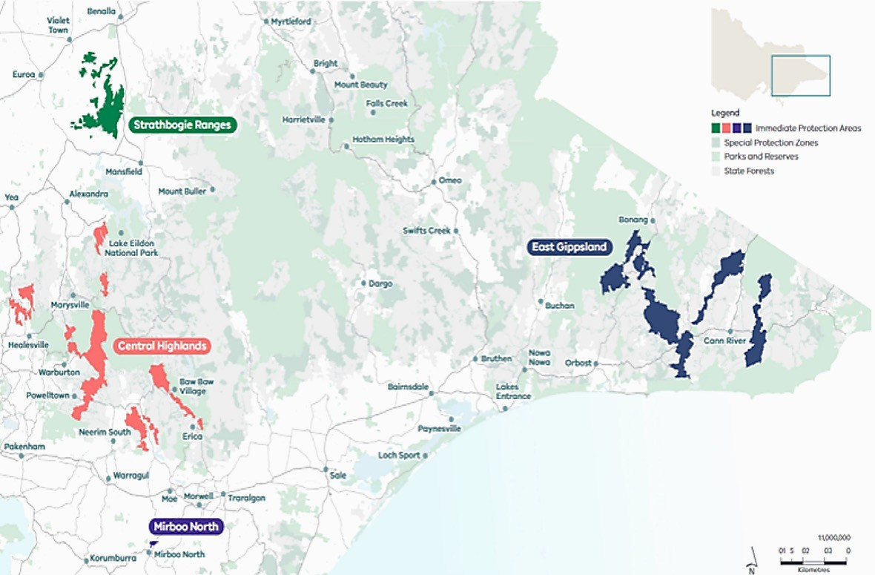

ASSESSMENT OF EARLY GOVERNMENT- ACCEPTED LCC RECOMMENDATIONS – SUPPLEMENTARY REPORT

In September 2022 VEAC was requested to undertake an assessment of government-accepted LCC recommendations made between 1973 and 1983 that have not been subsequently reviewed or superseded by more recent government decisions.
The assessment report was completed in June 2023. In the time available, a statewide analysis and detailed reviews of seven of 14 early LCC investigations that have extant government-accepted land use recommendations were completed. VEAC committed to complete a detailed review of the remaining seven early LCC investigations as resources permitted. This additional work was collated as a supplementary report, submitted to the Minister, and made available online in January 2024.

Expenditure
Expenditure, including salaries and on-costs, for the supplementary report to the assessment of government- accepted LCC recommendations for the 2023-24 financial year was $45,187.

DATA AND INFORMATION MANAGEMENT
As outlined in VEAC’s April 2023 report “Advice on Aspects of Public Land Use Information – Improving the VEACRecs25 dataset”, the VEACRecs25 dataset records those recommendations of VEAC and its predecessors which have been accepted by Government, for the period from 1971 onwards. This information source is therefore a key tool to help both the community and government agencies understand the purpose for which public land is to be managed.
In response to feedback from users, a work program is underway to update and improve the dataset including validation of pre-digital data and focus on integration and consistency of the dataset with other public land information sources.
Improving VEAC’s dataset allows for better quality outputs and improved analysis to support Government policy development and implementation. Ongoing work supports current reforms to public land legislation. Over the reporting period, the dataset has also been used to establish the extent of state forest in eastern Victoria and utilised in VEAC’s assessment of the values of state forests in the Central Highlands.

BILL BORTHWICK STUDENT SCHOLARSHIPS 2024
The Bill Borthwick Student Scholarships assist with some of the costs of research for students undertaking Honours, Masters or PhD research projects relating to public land in Victoria in the fields of natural sciences, humanities and social sciences, economics or politics. The scholarships were established in March 2011 to commemorate the 40th anniversary of the first meeting of the LCC and to honour the vision of the Hon Bill Borthwick, a central figure in establishing the LCC to advise government on the use of Victoria’s public land.
The 2024 scholarships totaling $8,000 were awarded to five recipients. The recipients of the 2024 scholarships were:

Harrison Croft, Monash University
“Becoming Birrarung: More than human histories of Victoria’s River”

Luke Florence, La Trobe University
“Mycorrhizal diversity in Australian temperate forests in the context of nitrogen deposition”

Zoe Gallaway-Beer, University of Adelaide
“Validating species distribution models for fire management and Mallee bird conservation- Wyperfeld National Park”

Emily McIntyre, University of Melbourne
“Hypogeous Fungi and the Endangered Long-Footed Potoroo; Distribution, Diversity and Mutualism”

Kimberley Peters, Deakin University
“Danger Noodles, Nope Ropes or Slinkys? The role of community attitudes and experiences in promoting tolerance and co-existence with snakes”

COMMITTEES
VEAC is required to establish a community reference group to provide advice in respect of each investigation. Community reference groups are not required in respect of assessments or advice unless directed by the Minister or specified in the terms of reference. VEAC may also appoint any committees that it considers necessary to assist with conduct of investigations.
There were no continuing groups and VEAC did not establish any community reference groups in 2023-24.

MEMBERSHIP OF EXTERNAL COMMITTEES
During 2023-24 VEAC chairperson Mellissa Wood was a member of the Eminent Panel for Community Engagement, the Great Outdoors Taskforce and the Commissioner for Environmental Sustainability Reference Group.

CONSULTANCIES

$10,000 or greater
In 2023-24, there were three consultancies where the total fees payable to the consultant were $10,000 or greater. The total expenditure incurred during 2023-24 in relation to these consultancies was $147,937 (exclusive of GST).
Details of individual consultancies are outlined on VEAC’s website at www.veac.vic.gov.au.

Less than $10,000
In 2023-24, there was one consultant engaged during the year, where the total fees payable to the consultant were less than $10,000. The total expenditure incurred during 2023-24 in relation to this consultancy was $7350 (exclusive of GST).

DECLARATION OF PECUNIARY INTERESTS
The Chairperson and all members completed Declarations of Private Interests.
Executive Officers Joan Phillips (to February) and Louise Persse (February onwards), and Senior Project Manager Paul Peake have also completed declarations.
All returns are confidential.

FINANCIAL INFORMATION
VEAC’s operating funds were provided through DEECA.
VEAC’s financial operations have not been separately audited. Audited statements are incorporated into the overall Financial Statements of DEECA’s Annual Report for the year ended 30 June 2024. The table below shows expenditure incurred. This includes expenditure for the Assessment of the values of state forests in the Central Highlands (see page 8), and the supplementary report to the Assessment of early government-accepted LCC recommendations (see page 11).

EXPENSES | 2023-24 ($) | 2022-23 ($) | 2021-22 ($) | 2020-21 ($) | 2019-20($)
Salaries and on costs | 1,429,084 | 1,193,021 | 929,130 | 866,437 | 896,835
Operating | 345,891 | 298,376 | 511,298 | 348,865 | 377,050
Total | 1,774,975 | 1,491,397 | 1,440,428 | 1,215,302 | 1,273,885

WORKFORCE DATA
On 30 June 2024 eight DEECA staff members (eight full time equivalent) were employed to provide support to VEAC, compared to nine staff (nine full time equivalent) on 30 June 2023. All employees during this year were covered by the Victorian Public Service Enterprise Agreement 2020. Employees have been correctly classified in workforce data collections.

 | 2023–24 |  |  |  | 2022–23
Classification | Number (headcount) | FTE | Ongoing full time (headcount) | Fixed term (headcount) | Number (headcount) | FTE | Ongoing full time (headcount) | Fixed term (headcount)
VPS 4 | 4 | 4 | 3 | 1 | 5 | 5 | 2 | 3
VPS 5 | 2 | 2 | 2 | 0 | 2 | 2 | 2 | 0
VPS 6 | 2 | 2 | 1 | 1 | 2 | 2 | 2 | 0
Total | 8 | 8 | 6 | 2 | 9 | 9 | 6 | 3
Notes:
- All figures reflect employment levels during the last full pay period in June of each year.
- Ongoing employees includes people engaged on an open-ended contract of employment.
- These staff are included in DEECA’s annual report workforce data.

COMPLIANCE
Compliance with the Building Act 1993
In accordance with the reporting directions, the annual report must include a statement about compliance with the building and maintenance provisions of the Building Act 1993. VEAC makes use of buildings and facilities controlled by DEECA to perform its functions and does not own or control any buildings.

Occupational Health and Safety
VEAC utilises DEECA’s Occupational Health and Safety policies and procedures.

Government Advertising Expenditure
Government policy requires disclosure of all Government advertising expenditure with a total media buy of
$100,000 or greater (exclusive of GST). No Government advertising expenditure was incurred by VEAC during the reporting period.

Summary Of Environmental Performance
The Government’s aim of improved environmental management is supported by a requirement that Departments disclose their ongoing performance in managing and reducing the environmental impacts of their office-based activities. VEAC makes use of DEECA offices and facilities to perform its functions and the reporting requirement of the office is met by DEECA. For further information please see the DEECA 2023-24 annual report.

Public Sector Values And Employment Principles
Victorian public sector employment and conduct principles are applied in the appointment and management of staff. VEAC follows policy and procedures used by DEECA, in accordance with government directives and the Public Administration Act 2004.

Local Jobs First
For the 2023-24 reporting period, VEAC did not undertake any projects subject to Local Jobs First Act 2003.

DataVic Access Policy
Consistent with the Victorian Government’s DataVic Access Policy (2012), VEAC intends that data tables that it may produce in the future will be available at www.data.vic.gov.au in machine readable format.

FREEDOM OF INFORMATION (FOI)
The Freedom of Information Act 1982 gives everyone the right to seek access to documents held by VEAC. This comprises documents both created by VEAC or supplied to VEAC by an external organisation or individual, and may also include maps, films, microfiche, photographs, computer printouts, computer discs, tape recordings and videotapes. It is worth contacting VEAC in the first instance to find out if you can access the information without making an FOI application.
FOI requests can be lodged online at www.ovic.vic.gov.au. Access to documents can also be obtained through a written request to DEECA’s Freedom of Information team, as detailed in s17 of the Freedom of Information Act 1982. When making an FOI request, applicants should ensure requests are in writing, and clearly identify what types of material/documents are being sought. Requests for documents in the possession of VEAC should be addressed to:

Freedom of Information Officer
Department of Energy, Environment, and Climate Action GPO Box 500
East Melbourne Vic 8002 foi.unit@deeca.vic.gov.au

The cost of an FOI application is $32.70; however, access charges may also be payable if the document pool is large, and the search for material, time consuming. Further information is available at www.deeca.vic.gov.au.

Operations
For the 12 months ending 30 June 2024 there were no requests. There were no requests outstanding at 30 June 2024.
The Act allows VEAC to refuse access, either fully or partially, to certain documents or information. Examples of documents that may not be accessed include: cabinet documents; some internal working documents; law enforcement documents; documents covered by legal professional privilege, such as legal advice; personal information about other people; and information provided to VEAC in-confidence.
If an applicant is not satisfied by a decision made about their request, under section 49A of the Act, they may seek a review by the Office of the Victorian Information Commissioner withing 28 days of receiving a decision letter.

PUBLIC INTEREST DISCLOSURES ACT 2012
The Public Interest Disclosures Act 2012 (PID Act) enables people to make disclosures about improper conduct by a public officer or a public body.
VEAC is a public body for the purposes of the PID Act.

WHAT IS A ‘PUBLIC INTEREST DISCLOSURE’?
A public interest disclosure is a complaint of corrupt or improper conduct or detrimental action by a public officer or a public body.
‘Improper or corrupt conduct’ involves substantial mismanagement of public resources, risk to public health or safety or the environment, or corruption.
‘Detrimental action’ is action taken against a person in reprisal for making a public interest disclosure.

HOW DO I MAKE A ‘PUBLIC INTEREST DISCLOSURE’?
You can make a public interest disclosure about VEAC or its board members, officers or employees by contacting DEECA or IBAC at the contact details provided below.
Please note that VEAC is not able to receive public interest disclosures.

HOW CAN I ACCESS DEECA’S PROCEDURES FOR THE PROTECTION OF PERSONS FROM DETRIMENTAL ACTION?
DEECA has established procedures for the protection of persons from detrimental action in reprisal for making a public interest disclosure about VEAC or its employees. You can access DEECA’s procedures on its website at www.deeca.vic.gov.au

CONTACTS

Department of Energy, Environment and Climate Action
Address: PO Box 500, East Melbourne Vic 3002 Website: www.deeca.vic.gov.au
Phone: 1800 903 877

Independent Broad-based Anti-Corruption Commission Victoria
Address: Level 1, North Tower, 459 Collins Street, Melbourne Victoria 3001. Mail: IBAC, GPO Box 24234, Melbourne Victoria 3000
Website: www.ibac.vic.gov.au Phone: 1300 735 135
Email: see the website above for the secure email disclosure process, which also provides for anonymous disclosures.

PRIVACY AND DATA PROTECTION ACT 2014
VEAC complies with the ten information privacy principles in place that help to form the Privacy and Data Protection Act 2014. This includes handling the collection of personal information in a responsible manner. The coordinator of privacy issues for DEECA is:
Senior Privacy Advisor
Department of Energy, Environment and Climate Action PO Box 500, East Melbourne VIC 3002
email: foi.unit@deeca.vic.gov.au.

RISK MANAGEMENT
VEAC relies on the DEECA risk management framework and internal audit of financial and other administrative systems which are used by the VEAC office. Please refer to the DEECA Annual Report for further information.
In addition, in relation to its purpose and strategic objectives, VEAC reviews and approves its risk management framework and policy annually. VEAC maintains a risk register of current and emerging risks and reviews them on a quarterly basis.

GIFTS, BENEFITS AND HOSPITALITY ATTESTATION
I, Louise Persse, Executive Officer of the Victorian Environmental Assessment Council, certify that:
- my public entity has policies and procedures in place that are consistent with the minimum requirements and accountabilities outlined in the Gifts, Benefits and Hospitality Policy Framework issued by the Public Sector Standards Commissioner; and
- staff are informed about these gifts, benefits and hospitality policies and procedures.

DISCLOSURE INDEX
The 2023-24 VEAC Annual Report is prepared in accordance with all relevant Victorian legislation. This index has been prepared to facilitate identification of VEAC’s compliance with statutory disclosure requirements.

LEGISLATION | REQUIREMENT | PAGE NO
Accountable Officer’s declaration
SD 5.2 Sign off requirements inside front cover
Charter and purpose
FRD 22 | Objectives, functions, powers and duties | 4
FRD 22 | Manner of establishment and responsible Minister | 4,7
FRD 22 | Nature and range of services provided | 4
Financial information
FRD 22 | Operational and budgetary objectives | 14
FRD 22 | Summary of the financial results | 14
Governance and organisational structure
FRD 22 | Occupational health and safety policy | 15
FRD 22 | Employment and conduct principles | 15
FRD 29 | Workforce data disclosures | 14
Other information
FRD 10 | Disclosure index | 19,20
FRD 25 | Local Jobs First Act disclosures | 15
FRD 22 | Details of consultancies in excess of $10 000 | 13
FRD 22 | Details of consultancies under $10 000 | 13
FRD 22 | Disclosure of government advertising expenditure | 15
FRD 22 | Application and operation of Freedom of Information Act 1982 | 16
FRD 22 | Compliance with Building Act 1993 | 16
FRD 22 | Application and operation of Public Interest Disclosures Act 2012 | 17
FRD 24 | Reporting of environmental data by government entities | 15
FRD 22 | Statement of availability of other information | 21
SD 4.5.5 | Risk management compliance attestation | 18
 | Gifts, benefits and hospitality attestation | 18
SD 4.2 | General information requirements | Entire document
MRO | Compliance with DataVic Access Policy | 15

Legislation
Victorian Environmental Assessment Council Act 2001 |  | 4
Building Act 1993 |  | 15
Freedom of Information Act 1982 |  | 16
Public Interest Disclosures Act 2012 |  | 17
Local Jobs Act 2003 |  | 15
Print and Design
FRD 30 | Standard requirements for the design and print of annual reports | Entire document

ACRONYMS
FRD – Financial Reporting Directions SD – Standing Directions
MRO – Model Report of Operations

STATEMENT OF AVAILABILITY OF OTHER INFORMATION

ADDITIONAL INFORMATION AVAILABLE ON REQUEST
In compliance with the requirements of the Standing Direction of the Minister for Finance, details in respect of the items listed below have been retained by VEAC and are available on request, subject to the provisions of the FOI Act.
This information is available on request from:
Louise Persse, Executive Officer, Victorian Environmental Assessment Council Phone: 1800 134 803
Email: veac@deeca.vic.gov.au

INFORMATION AVAILABLE ON THE COUNCIL’S WEBSITE
Details of the following items are available at VEAC’s website www.veac.vic.gov.au.
- Publications produced by the agency about itself

ADDITIONAL INFORMATION INCLUDED IN ANNUAL REPORT
Details in respect of the following items have been included in this report:
- A statement that declarations of pecuniary interests have been duly completed by all relevant officers
- Major research and development activities undertaken – see Investigations and Assessments
- Major promotional, public relations and marketing activities undertaken to develop community awareness of VEAC and its services – see Investigations and Assessments
- A list of major committees sponsored by the entity, the purposes of each committee and the extent to which the purposes have been achieved – see Committees
- Consultancies and availability of further information about these – see Consultancies.

INFORMATION THAT IS NOT APPLICABLE TO VEAC
The following information is not relevant to VEAC for the reasons set out below:
- Details of shares held by a senior officer as nominee, or held beneficially in a statutory authority or subsidiary - Nil
- Overseas travel undertaken including a summary of the objectives and outcomes of each visit - Nil
- Details of changes in prices, fees, charges and levies charged - Nil
- Assessments and measures undertaken to improve the Occupational Health and Safety of employees #
- A general statement on industrial relations within the entity and details of time lost through industrial accidents and disputes #
- Major external reviews that were carried out on VEAC - Nil # See DEECA Annual Report 2023-24.

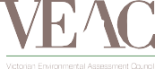


veac.vic.gov.au

