
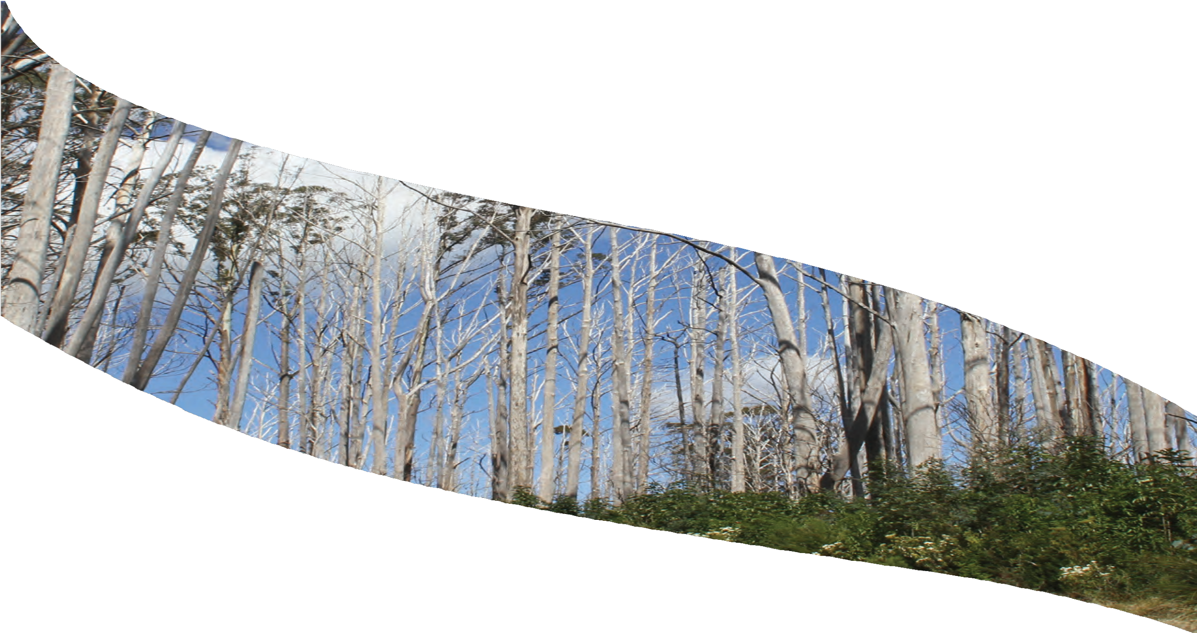



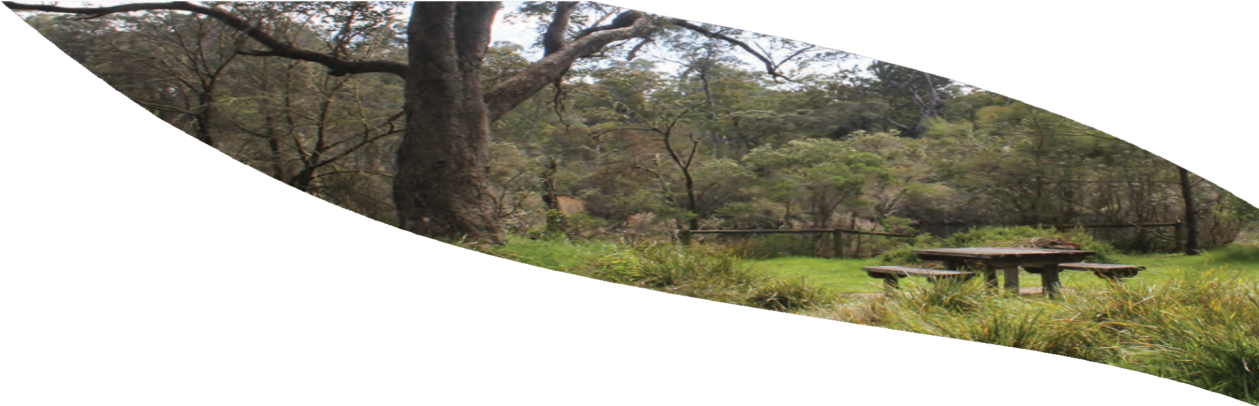

2024–25

Victorian Environmental Assessment Council
ANNUAL REPORT

Steve Dimopoulos MP Minister for Environment 8 Nicholson St
East Melbourne VIC 3002

Dear Minister
In accordance with the requirements of Section 14(1) of the Victorian Environmental Assessment Council Act 2001, the Victorian Environmental Assessment Council is pleased to submit to you its twenty-third annual report, covering our activities for the period 1 July 2024 to 30 June 2025.

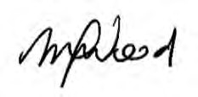
Mellissa Wood Chairperson
Victorian Environmental Assessment Council 25 September 2025

© State of Victoria, Victorian Environmental Assessment Council 2025.

This work is licensed under a Creative Commons Attribution 4.0 International licence. You are free to re-use the work under that licence, on the condition that you credit the State of Victoria as author. The licence does not apply to any images, photographs or branding, including the Victorian Coat of Arms, the Victorian Government logo and the VEAC logo. To view a copy of this licence, visit https://creativecommons.org/ licenses/
ISSN: 2207-0613 Online/PDF

Accessibility
If you would like to receive this publication in an alternative format, please email: veac@deeca.vic.gov.au. This document is also available on the internet at www.veac.vic.gov.au

Disclaimer
This publication may be of assistance to you but the State of Victoria and its employees do not guarantee that this publication is without flaw of any kind or is wholly appropriate for your particular purposes and therefore disclaims all liability for any error, loss or other consequence which may arise from your relying on any information in this publication.

CONTENTS PAGE
ACKNOWLEDGMENT OF COUNTRY 2
CHAIRPERSON’S FOREWORD 3
VICTORIAN ENVIRONMENTAL ASSESSMENT COUNCIL 4
INVESTIGATIONS 8
ASSESSMENTS AND ADVICE 8
- ASSESSMENT OF THE VALUES OF STATE FORESTS 8
IN THE CENTRAL HIGHLANDS
- ASSESSMENT OF THE VALUES OF STATE FORESTS 11
IN EASTERN VICTORIA
- DATA AND INFORMATION MANAGEMENT 14
BILL BORTHWICK STUDENT SCHOLARSHIPS 2025 15
COMMITTEES 16
MEMBERSHIP OF EXTERNAL COMMITTEES 16
CONSULTANCIES 16
OPERATIONAL GOVERNANCE 16

We acknowledge and respect Victorian Traditional Owners as the original custodians of Victoria’s land and waters, their unique ability to care for Country and deep spiritual connection to it. We honour Elders past and present whose knowledge and wisdom has ensured the continuation of culture and traditional practices. We are committed to genuinely partner, and meaningfully engage, with Victoria’s Traditional Owners and Aboriginal communities to support self-determination and to care for Country, including spiritual and cultural practices and their aspirations for the future.

CHAIRPERSON’S FOREWORD

I am pleased to present the 2024-2025 annual report of the Victorian Environmental Assessment Council (VEAC) to the Minister for Environment, the Hon. Steve Dimopoulos MP, in accordance with the Victorian Environmental Assessment Council Act 2001.
This year has been marked by significant change and achievement for VEAC. VEAC welcomed the appointment of Marcus Stewart to Council and the reappointment of Mellissa Wood and Nicola Ward, with Dave Kendal and Jennifer Wolcott continuing their valued service. In May 2025, we farewelled acting Executive Officer Louise Persse and welcomed VEAC’s Senior Program Manager, Paul Peake into the acting Executive Officer role. After many years calling Lonsdale Street home, VEAC relocated to DEECA offices on Nicholson Street. This required a major effort to comprehensively archive information from 53 years of investigations and assessments.
VEAC has continued to advance new partnerships and innovative approaches to investigating the conservation and use of Victoria’s public lands. Following on from VEAC’s previous Statewide Assessment and Advice on Aspects of Public Land Use Information, staff assisted DEECA with work to support the future implementation of the proposed Victorian Public Land Act. Critically, and informed by the Yoorrook Justice Commission process, VEAC continues to learn from and support First Nations biocultural approaches, aspirations and self-determination in Caring for Country.
In October 2024, Minister Dimopoulos requested VEAC undertake an Assessment of the values of state forests in eastern Victoria to support the public consultation and recommendations by the Great Outdoors Taskforce. Our assessment identified significant biodiversity values and areas of highest habitat importance, while recognising the forests’ vital role in regional economies through recreation, tourism and other activities. With timber harvesting now ceased, VEAC identified the key threats of the legacy of logging, climate change as a risk accelerator, inappropriate fire regimes, weeds and pests and poor land management.
VEAC completed its Assessment of the values of state forests in the Central Highlands, Interim Report in December 2023 to inform the work of the Eminent Panel for Community Engagement. VEAC will complete and publish its final assessment when it receives the panel’s recommendations. This final report will include an assessment of potential economic implications of any recommended land use changes.
VEAC continues updating the VEACRecs25 dataset, improving integration with other public land information sources, and supporting Public Land Act reforms through data provision and expertise. VEAC maintained its long-standing commitment to developing environmental leaders through the Bill Borthwick Scholarship program, supporting five scholars in undertaking innovative research relating to public land.
Looking ahead, VEAC will continue to support the government’s priorities, bringing deep independent expertise and a long term perspective to the challenges and opportunities of managing our public lands to benefit communities and the environment. We recognize the need to work withing current resourcing constraints and new opportunities to work collaboratively and support First Peoples self-determination.
I extend sincere gratitude to state government departments and agencies, Traditional Owners, local governments, the scientific community, organisations, community groups and members of the public for their ongoing assistance and support. Special thanks go to VEAC’s past and current dedicated expert staff for their commitment across this year of change.

Mellissa Wood
Chairperson, Victorian Environmental Assessment Council

OUR PURPOSE
VEAC is established under the Victorian Environmental Assessment Council Act 2001 (the VEAC Act) to provide independent and strategic advice to the Victorian Government on matters relating to the protection and ecologically sustainable management of the environment and natural resources of Victoria’s public land (refer to sections 4 and 5 of the VEAC Act).

OUR VALUES
- We think long term
- We use evidence and expertise as the foundation of our work
- We act conscientiously in the public interest
- We seek out and listen to diverse voices
- We treat everyone with respect
- We work independently and are accountable for our activities

OUR FUNCTIONS
VEAC:
- carries out investigations and assessments and provides advice as requested by the Minister for Environment on matters relating to the protection and ecologically sustainable management of the environment and natural resources of public land
- carries out any other functions conferred by the VEAC Act or any other Act (refer to section 6 of the VEAC Act)
In carrying out investigations and making recommendations VEAC is required to have regard to:
- the principles of ecologically sustainable development
- the need to conserve and protect biological diversity
- the need to conserve and protect any areas which have ecological, natural, landscape or cultural interest or significance, recreational value or geological or geomorphological significance
- the need to provide for the creation and preservation of a comprehensive, adequate and representative system of parks and reserves within the State of Victoria
- the existence of any international treaty ratified by the Commonwealth of Australia which is relevant to the investigation
- any agreement at a national, inter-state or local government level into which the Government of Victoria has entered, or under which the Government of Victoria has undertaken any obligation in conjunction with the Commonwealth, a state, territory or municipal council, which relates to the subject matter of the investigation
- the potential environmental, social and economic consequences of implementing the proposed recommendations
- any existing or proposed use of the environment or natural resources
Powers held by VEAC include the ability to appoint committees and, with the consent of the relevant Minister, make use of the services of any person employed in DEECA (refer to section 7 of the VEAC Act).
A website containing general information about VEAC’s role, operation and current and past investigations and assessments is available at www.veac.vic.gov.au. The site also contains links to past investigations and studies conducted by VEAC’s predecessors the Environment Conservation Council (ECC) and the Land Conservation Council (LCC).

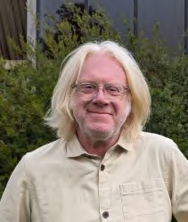
(L-R) Mellissa Wood, Dave Kendal, Nicola Ward, Marcus Stewart, Jennifer Wolcott.

VEAC members are appointed under the VEAC Act. Members appointed from 1 July 2024 to 30 June 2026 were Dave Kendal and Jennifer Wolcott. Members reappointed from 7 July to 30 September 2024 and 17 December 2024 to 30 June 2026 were Mellissa Wood (Chairperson) and Nicola Ward. Marcus Stewart was appointed as a member from 17 December 2024 to 30 June 2026.

Mellissa Wood (Chairperson)
Mellissa Wood brings over 30 years of expertise in scientific and policy leadership within international development, conservation, environmental management, and sustainable food systems. Her career includes Senior Executive roles with the Australian Government, as well as prominent international organisations, including the UN Food and Agriculture Organisation (FAO) and CGIAR.
Mellissa has served as General Manager of the Australian Centre for International Agricultural Research (ACIAR) and as a key member of CGIAR’s System Council and System Management Board. Her extensive international experience encompasses Sub-Saharan Africa, Southeast Asia, and the Pacific. Notably, she was the Director of the Australian International Food Security Research Centre in Eastern and Southern Africa and worked at FAO in Rome as Director of Programs, at the Global Crop Diversity Trust.
Additionally, she spent 15 years at the Bureau of Rural Sciences within the Federal Department of Agriculture, Forestry and Fisheries, where she provided critical scientific advice for natural resource management.
Currently, Mellissa is a member of the Eminent Panel for Community Engagement and The Great Outdoors Taskforce, and she serves as a Visiting Scientist at CSIRO. She holds a Master of Public Policy from Crawford School, Australian National University, a Bachelor of Science in Resource and Environmental Management from Australian National University and is a graduate of the Australian Institute of Company Directors and a member of the Royal Society of Victoria.

Dave Kendal
Dr Dave Kendal is an internationally recognised expert on urban nature and ecology, biodiversity conservation, social values for the environment and public perceptions of nature. He is Director of Future in Nature Pty Ltd which provides consulting advice on urban nature, social values and conservation, after researching and teaching about the reciprocal effects of people on nature in cities and beyond for 20 years. He has worked at the Australian Research Centre for Urban Ecology, a division of the Royal Botanic Gardens Melbourne, and at the University of Melbourne, and the University of Tasmania. Dave has been a key contributor to many policies and programs that have improved social-ecological systems in Australia and around the world, including the City of Melbourne’s urban forest strategy and precinct planning process, the global Climate Change Alliance of Botanic Gardens Climate Assessment Tool, the NSF funded Nature-based Solutions for Urban Resilience in the Anthropocene (NATURA) network, the City of Auckland’s urban nature strategy, Australia’s National Environmental Science Program, Melbourne Water and DELWP community values assessments. He has held expert advisory roles under Australia’s EPBC Act, for the European Commission, the Technical University of Munich, BGANZ and the Living Melbourne Strategy. He was a member of Australia’s Threatened Species Scientific Committee from 2015-2019.

Nicola Ward
Nicola Ward has held senior positions in the state governments of New South Wales and Victoria and local government, with extensive public policy experience in environment and natural resource management. She has policy and program expertise in environment, sustainability and climate change; strategic planning, land use and development; community infrastructure planning; sport, recreation and open space planning. She is experienced in organisation strategy, business transformation and risk and performance.
She holds a range of volunteer positions including Board Director of the Natural Resources Conservation League (Vic), Independent Chair of the Southern Brown Bandicoot Regional Recovery Group and committee member of various community groups. She was previously a Sessional Member of Planning Panels Victoria, a Board Director of the Port Phillip and Western Port Catchment Management Authority and Alternate Director of the Mornington Peninsula and Western Port Biosphere Reserve Foundation. Nicola has a Masters degree in Social Science (Environment and Planning) with Distinction and an Honours degree in Social Science. Nicola is a member of the Australian Institute of Company Directors.

Marcus Stewart
Marcus Stewart has 12 years’ executive experience in government and Traditional Owner corporations and 15 years of non-executive directorship experience. He currently operates his own consultancy, Marcus Stewart Consultancy, where he provides corporate coaching, strategic corporate solutions, and insight on how to work with Traditional Owner Groups.
Marcus was the inaugural Co-Chair of the First Peoples’ Assembly of Victoria and former Chief Executive Officer of the Federation of Victorian Traditional Owner Corporation. He is currently a Director with the Taungurung Land and Waters Council and was a Member of the Indigenous Voice Referendum Working Group.
Marcus has completed a Development Psychiatry course, a course in Clinical Family Therapy and a MURRA Business Master Class with Melbourne Business School. He has recently been appointed as a Principal Fellow at Melbourne Law School.

Jennifer Wolcott
Jennifer Wolcott has had more than 30 years’ experience in environmental and natural resource management and regional development in Victoria. She has held senior executive positions in a number of Victorian government departments, the Environment Protection Authority, Parks Victoria, Regional Development Victoria and Emergency Management Victoria where she has led regulatory and public policy reform, corporate strategy, investigations and grant programs.
Jennifer has been a board director of the Royal Botanic Gardens Victoria, the Institute of Public Administration Victoria and Trust for Nature. She has been a member of the Victorian Coastal Council, National Parks Advisory Council and Reference Area Advisory Committee. Jennifer has a Bachelor of Forest Science (Hons) from the University of Melbourne, is a graduate of the Australian Institute of Company Directors, the Women on Boards SX program and is a Fellow of the Institute of Public Administration Victoria.

Steve Dimopoulos MP, Minister for Environment, was responsible for VEAC from 1 July 2024 to 30 June 2025.

VEAC ACTIVITIES
The Council met formally 10 times during the 2024-25 financial year, including two meetings when there was a gap before the reappointment of two members.

VEAC members’ meeting attendance from 1 July 2024 to 30 June 2025 is listed below.

NAME | ATTENDANCE  (number of meetings)
Mellissa Wood | 8 of 8
Dave Kendall | 10 of 10
Marcus Stewart | 2 of 5
Nicola Ward | 8 of 8
Jennifer Wolcott | 10 of 10

ADMINISTRATION
The VEAC office is located on level 1, 8 Nicholson St, East Melbourne, 3002.
Email veac@deeca.vic.gov.au
Website www.veac.vic.gov.au
Executive Officer Paul Peake

The Executive Officer is responsible for managing the office and staff.

INVESTIGATIONS
VEAC did not undertake any investigations in 2024-25.

ASSESSMENTS AND ADVICE

ASSESSMENT OF THE VALUES OF STATE FORESTS IN THE CENTRAL HIGHLANDS
On 20 March 2023 the then Minister for Environment, Ingrid Stitt MP, requested that VEAC assess the values of Immediate Protection Areas in the Central Highlands and East Gippsland and adjacent state forests. The assessment informed the work of the Eminent Panel for Community Engagement (the Panel) which was Chaired by Karen Cain, and included the Chairperson of VEAC, Mellissa Wood. The government established the Panel to undertake public consultation and develop recommendations to the Minister on the future uses of the assessment area.
VEAC’s terms of reference were subsequently amended to extend its reporting date and assessment area in line with the Panel’s work. The reporting date was first extended on 18 June 2023. The terms of reference were amended on 11 September 2023 to further extend the reporting date and to redefine the scope of the assessment to exclude East Gippsland but include all state forests in the Central Highlands Regional Forest Agreement area. On 31 July 2024, the Minister extended the date for VEAC to submit its final report to one month after the government publicly releases the Panel’s report on Central Highlands state forest. The government has yet to release the Panel’s report.
VEAC published its interim assessment of the matters specified in (a) to (d) of its terms of reference (see page 9) in December 2023. This assessment informed the Panel’s community engagement and development of recommendations to the Minister on the future uses of the state forests of the Central Highlands. For more information on the Panel see Eminent Panel for Community Engagement. As land and rights holders Traditional Owner Corporations are formally represented on the Panel.
VEAC’s final report will be publicly released following release of the Panel’s report and will include, as required by its terms of reference, an assessment of the potential economic implications of proposed land use changes recommended by the Panel.
In parallel with VEAC’s assessment, Victorian Traditional Owners are undertaking significant biocultural assessments to support cultural land management in the Central Highlands region. VEAC is committed to supporting the self-determined role of traditional knowledge and the integration of biocultural knowledge into land use planning and decision-making, as well as continuing the exploration of how to bring together knowledge with Victorian Traditional Owners over time.

Expenditure
Expenditure, including salaries and on-costs, for the assessment of the values of state forests in the Central Highlands for the 2024-25 financial year was $154,849.

Terms Of Reference

Assessment of the values of state forests in the Central Highlands
Pursuant to section 26B of the Victorian Environmental Assessment Council Act 2001, the Minister for Environment hereby requests the Victorian Environmental Assessment Council (the Council) to carry out an assessment of the values of state forests in the Central Highlands. The state forest in the Central Highlands are shown on the accompanying map.
The assessment will inform the work of an Eminent Panel for Community Engagement (the Panel) in its provision of advice and recommendations to the Minister for Environment on the future uses of state forest in the Central Highlands.
The purpose of the assessment is to:
- identify the biodiversity, ecological and geological and geomorphological values of the specified area
- identify the cultural heritage, social and economic values of the specified area
- identify the current and likely future threats to those values, including climate change
- identify the typical land use categories commensurate with the identified values
- assess the potential economic implications of proposed land use changes recommended by the Panel and provided to the Council.
This assessment will build upon the Council’s Conservation values of state forests - Assessment report
(2017) by providing a more localised assessment of the values of these areas.
The Council is required to consider the values referred to above at the relevant state, regional and local levels, including their occurrence in existing protected areas and on other public land.
This request is for an assessment and report on the above values. Public consultation and recommendations are not required.
The Council will engage with the Panel regarding the content of the Council’s assessment.
The Council must publish its assessment of the matters specified in paragraphs (a) to (d) above by 15 December 2023 and submit a report on the completed assessment by one month after the Government publicly releases the Panel’s report on Central Highlands state forest.

State forest in Central Highlands (light green) and Immediate Protection Areas (red lines)
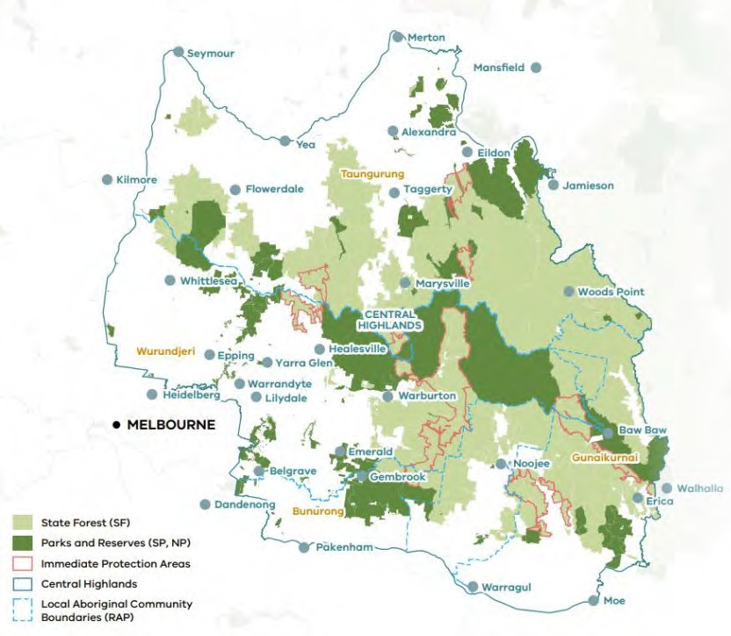

ASSESSMENT OF THE VALUES OF STATE FORESTS IN EASTERN VICTORIA

On 25 October 2024 the Minister for Environment, Steve Dimopoulos MP, requested that VEAC assess the values of state forests in eastern Victoria in accordance with the terms of reference on page 12.
The purpose of the assessment was to identify the natural, cultural, social and economic values of state forests and threats to them to inform the work of the Great Outdoors Taskforce (the Taskforce). The government established the Taskforce following cessation of logging in Victoria to undertake public consultation and make recommendations on the future use and management of state forests. The Taskforce was Chaired by Lisa Neville and included the Chairperson of VEAC, Mellissa Wood. VEAC shared data and information iteratively with the Taskforce, providing written material, briefings and answers to enquiries on multiple occasions prior to finalising and publishing its assessment report on 28 April 2025.
Traditional Owner involvement was self-determined and through the Taskforce. Eastern Victoria’s magnificent forests reflect tens of thousands of years of Traditional Owner caring for Country. VEAC believes the region provides many opportunities for Traditional Owners to care for Country, for collaborative stewardship and multiple-use, and active and adaptive management to restore the health and build the resilience of these forests for future generations. Current transformations in public land management – including modernising legislation, timber harvesting cessation, and Treaty negotiations with First Peoples – present opportunities to build collaborative governance and management partnerships with communities to restore and maintain healthy forests.
VEAC’s assessment found that these forests contain high biodiversity values, and identified areas of highest habitat value. The region’s forests provide habitat for several hundred threatened species including the long-footed potoroo, greater glider, powerful owl, Orbost spiny crayfish and numerous rare plants.
The forests are also highly valued by a diverse range of users who enjoy being in nature and underpin the economy of the region including through recreation, tourism, mining, water for farming and apiculture – providing important social and wellbeing benefits.
VEAC’s report outlines key threats to these values including the legacy of logging, climate change as a risk accelerator, inappropriate fire regimes, weeds and pests and poor management.

Expenditure
Expenditure, including salaries and on-costs, for the Assessment of the Values of state forests in Eastern Victoria for the 2024-25 financial year was $596,131.

Terms Of Reference

Assessment of the values of State forests in the eastern Victoria
Pursuant to section 26B of the Victorian Environmental Assessment Council Act 2001, the Minister for Environment hereby requests the Victorian Environmental Assessment Council (the Council) to carry out an assessment of the values of State forests within eastern Victoria (the assessment). This includes the
1.8 million hectares of State forests subject to the timber harvesting allocation order and relevant adjacent State forests within the North East, Gippsland and East Gippsland Regional Forest Agreement Areas. The approximate assessment area is shown on the accompanying map.
The assessment will inform the work of the Great Outdoors Taskforce in its provision of advice and recommendations to the Minister for Environment on the future use and management of state forest areas. The Great Outdoors Taskforce is tasked with making recommendations to government about the use of land within the assessment area. Recommendations may consider areas of high conservation value, areas suitable for enhanced tourism and outdoor recreation experiences, and opportunities for Traditional Owner management. In making its recommendations the Great Outdoors Taskforce will consider the findings of the assessment, as well as input from Traditional Owners, a range of stakeholders at a local and regional level, and the general community.
The purpose of the assessment is to identify:
- the biodiversity, ecological, geological and geomorphological values of the specified area
- the historic heritage, social and economic values of the specified area
- the current and likely future threats to those values, including climate change
This assessment will build upon the Council’s Conservation values of state forests - Assessment report (2017) by providing a more localised assessment of the values of these areas. The Council is not required to consider areas recently covered in its Assessment of the values of Immediate Protection Areas in the Strathbogie Ranges and Mirboo North (2022) and the Assessment of the values of the Immediate Protection Areas in the Central Highlands (final report in preparation).
The Council is required to consider the values referred to above at the relevant state, regional and local levels, including the occurrence in existing protected areas and on other public land.
This request is for an assessment and report on the above values. The Council is not required to undertake public consultation or make recommendations.
The Council will share information with the Great Outdoors Taskforce as the assessment progresses and keep the Taskforce updated on the progress of developing its report.
The Council must publish its assessment of the matters specified in paragraphs (a) to (c) above within six months of making of this request.

Map 1: Approximate location of assessment area in Victoria (grey hatch) including Allocation Order (grey shading) and State forests (light green shading).

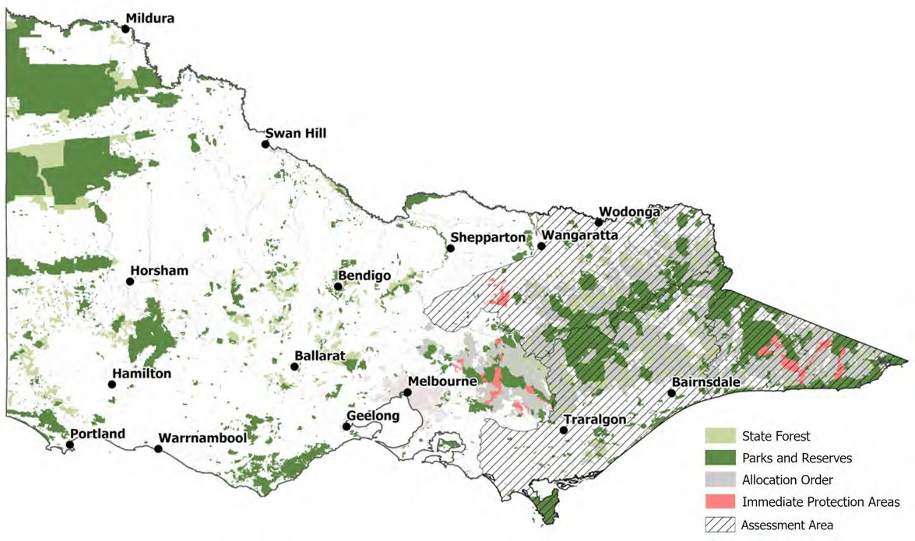

The curation of spatial and other data on public land across Victoria is a core component of VEAC’s work. As outlined in VEAC’s April 2023 report Advice on Aspects of Public Land Use Information – Improving the VEACRec25 Dataset, the VEACRecs25 dataset records those recommendations of VEAC and its predecessors which have been accepted by government from 1971 onwards. This information source is a key tool to help both the community and government agencies understand the purpose for which public land is to be managed and is a key input in the development of the Public Land Management Record component of the government’s landmark public land reforms.
In response to feedback from users, a work program is underway to update and improve the dataset including validation of pre-digital data and focus on integration and consistency of the dataset with other public land information sources.
Improving VEAC’s dataset allows for better quality outputs and improved analysis to support government policy development and implementation. Ongoing work supports current reforms to public land legislation. Over the reporting period, the dataset has also been used to establish the extent of state forest in eastern Victoria for VEAC’s assessment of the values of those forests to inform the work of the Great Outdoors Taskforce.

The Bill Borthwick Student Scholarships assist with the costs of research for students undertaking honours, masters or PhD research projects relating to public land in Victoria in the fields of natural sciences, humanities and social sciences, economics or politics. The scholarships were established in March 2011 to commemorate the 40th anniversary of the first meeting of VEAC’s predecessor the Land Conservation Council (LCC) and to honour the vision of the Hon Bill Borthwick, a central figure in establishing the LCC to advise government on the use of Victoria’s public land.
VEAC continues to receive high quality applications for this competitive scholarship and has now awarded scholarships to 213 students in nine academic institutions. The supported projects have covered all post- graduate degree levels and the full range of natural, cultural and social dimensions of pubic land in Victoria.

The 2025 scholarships totalling $8,000 were awarded to five recipients.

Rhys Healy, Federation University
‘Holes to Recovery: Investigating Hollow Resources and Occupancy by Greater Gliders at the Limit of their Species Range’

Patrick Kennedy, University of Melbourne
‘A palaeoecological analysis of fires, floods, and vegetation to inform Wurundjeri Woi Wurrung-led restoration of urban billabongs’

Isabella Martin, Deakin University
‘Wildlife and camping in Victoria’

Victoria Schwarz, Monash University
‘Hydroclimate in the Wimmera Catchment from the Quaternary to Anthropocene, South-East Australia’

Shuqiao Zhang, University of Melbourne
‘Assessing Fire Susceptibility of Alpine Ash Trees Under Different Management Scenarios’

VEAC is required to establish a community reference group to provide advice on each investigation or as directed by the Minister or specified in terms of reference. VEAC may also appoint any committees that it considers necessary to assist with conduct of investigations.
There were no continuing VEAC community reference groups and VEAC did not establish any community reference groups in 2024-25.

MEMBERSHIP OF EXTERNAL COMMITTEES
During 2024-25 VEAC Chairperson Mellissa Wood was a member of the Eminent Panel for Community Engagement, the Great Outdoors Taskforce and the Commissioner for Environmental Sustainability Reference Group. Dave Kendal was a member of the Heritage Advisory Committee for the National Trust (Vic) and the Oceania co-lead of Global Roadmap for Urban Nature-based Solutions for the US-based NATURA Network. For part of the year he was a member of the European Commission’s Evaluation Committee for the Biodiversa+ scheme, and co-led the Oceania region of the IUCN’s specialist working group on Urban Ecosystems.

CONSULTANCIES

$10,000 or greater
In 2024-25, there were two consultancies where the total fees payable to the consultant were $10,000 or greater. The total expenditure incurred during 2024-25 in relation to these consultancies was $37,480 (exclusive of GST).

Less than $10,000
In 2024-25, there was no consultants engaged during the year, where the total fees payable to the consultant were less than $10,000.

DECLARATION OF PECUNIARY INTERESTS
The Chairperson and all members completed Declarations of Private Interests.
Executive Officers Louise Persse (1 July 2024 to 25 April 2025) and Paul Peake (28 April to 30 June 2025) have also completed declarations.
All returns are confidential.

VEAC’s operating funds were provided through DEECA.
VEAC’s financial operations have not been separately audited. Audited statements are incorporated into the overall financial statements within DEECA’s Annual Report for the year ended 30 June 2025. The table below shows expenditure incurred. This includes expenditure for the Assessment of the values of state forests in the Central Highlands and the Assessment of the values of state forests in eastern Victoria (see page 8-13).

EXPENSES | 2024-25 ($) | 2023-24 ($) | 2022-23 ($) | 2021-22 ($) | 2020-21 ($)
Salaries and on costs | 1,182,920 | 1,429,084 | 1,193,021 | 929,130 | 866,437
Operating | 226,181 | 345,891 | 298,376 | 511,298 | 348,865
Total | 1,409,101 | 1,774,975 | 1,491,397 | 1,440,428 | 1,215,302

WORKFORCE DATA
On 30 June 2025 six staff members (six full time equivalent) were employed to provide support to VEAC, compared to eight staff (eight full time equivalent) on 30 June 2024. All employees were covered by the Victorian Public Service Enterprise Agreement 2024. Employees have been correctly classified in workforce data collections.

 | 2024–25 |  |  |  | 2023–24
Classification | Number (headcount) | FTE | Ongoing full time  (headcount) | Fixed term (headcount) | Number (headcount) | FTE | Ongoing full time  (headcount) | Fixed term (headcount)
VPS 4 | 3 | 3 | 2 | 1 | 4 | 4 | 3 | 1
VPS 5 | 2 | 2 | 2 | 0 | 2 | 2 | 2 | 0
VPS 6 | 1 | 1 | 1 | 0 | 2 | 2 | 1 | 1
Total | 6 | 6 | 5 | 1 | 8 | 8 | 6 | 2
Notes:
- All figures reflect employment levels during the last full pay period in June of each year.
- Ongoing employees includes people engaged on an open-ended contract of employment.
- These staff are included in DEECA’s annual report workforce data.

Compliance with the Building Act 1993
In accordance with the reporting directions, the annual report must include a statement about compliance with the building and maintenance provisions of the Building Act 1993. VEAC makes use of buildings and facilities controlled by DEECA to perform its functions and does not own or control any buildings.

Occupational Health and Safety
VEAC uses DEECA’s Occupational Health and Safety policies and procedures.

Government Advertising Expenditure
Government policy requires disclosure of all government advertising expenditure with a total media buy of $100,000 or greater (exclusive of GST). No government advertising expenditure was incurred by VEAC during the reporting period.

SUMMARY OF ENVIRONMENTAL PERFORMANCE
The government’s aim of improved environmental management is supported by a requirement that departments disclose their ongoing performance in managing and reducing the environmental impacts of their office-based activities. VEAC makes use of DEECA offices and facilities to perform its functions and the reporting requirement of the office is met by DEECA. For further information please see the DEECA 2024-25 annual report.

PUBLIC SECTOR VALUES AND EMPLOYMENT PRINCIPLES
Victorian public sector employment and conduct principles are applied in the appointment and management of staff. VEAC follows policy and procedures used by DEECA, in accordance with government directives and the Public Administration Act 2004.

LOCAL JOBS FIRST
For the 2024-25 reporting period, VEAC did not undertake any projects subject to Local Jobs First Act 2003.

DATAVIC ACCESS POLICY
Consistent with the Victorian Government’s DataVic Access Policy (2012), VEAC intends that data tables that it may produce in the future will be available at www.data.vic.gov.au in machine readable format.

The Freedom of Information Act 1982 (FOI Act) gives everyone the right to seek access to documents held by VEAC. This comprises documents both created by VEAC or supplied to VEAC by an external organisation or individual, and may also include maps, films, microfiche, photographs, computer printouts, computer discs, tape recordings and videotapes. It is worth contacting VEAC in the first instance to find out if you can access the information without making an FOI application.
FOI requests can be lodged online at ovic.vic.gov.au. Access to documents can also be obtained through a written request to DEECA’s Freedom of Information team, as detailed in s17 of the Freedom of Information Act 1982. When making an FOI request, applicants should ensure requests are in writing, and clearly identify what types of material/documents are being sought. Requests for documents in the possession of VEAC should be addressed to:

Freedom of Information Officer
Department of Energy, Environment and Climate Action GPO Box 500
East Melbourne Vic 8002 foi.unit@deeca.vic.gov.au

The cost of an FOI application is $32.70; however, access charges may also be payable if the document pool is large, and the search for material, time consuming. Further information is available at www.deeca.vic.gov.au.

Operations
For the 12 months ending 30 June 2025 there were no requests. There were no requests outstanding at 30 June 2025.
The FOI Act allows VEAC to refuse access, either fully or partially, to certain documents or information. Examples of documents that may not be accessed include: cabinet documents; some internal working documents; law enforcement documents; documents covered by legal professional privilege, such as legal advice; personal information about other people; and information provided to VEAC in-confidence.
If an applicant is not satisfied by a decision made about their request, under section 49A of the Act, they may seek a review by the Office of the Victorian Information Commissioner withing 28 days of receiving a decision letter.

The Public Interest Disclosures Act 2012 (PID Act) enables people to make disclosures about improper conduct by a public officer or a public body.
VEAC is a public body for the purposes of the PID Act.

WHAT IS A ‘PUBLIC INTEREST DISCLOSURE’?
A public interest disclosure is a complaint of corrupt or improper conduct or detrimental action by a public officer or a public body.
‘Improper or corrupt conduct’ involves substantial mismanagement of public resources, risk to public health or safety or the environment, or corruption.
‘Detrimental action’ is action taken against a person in reprisal for making a public interest disclosure.

HOW DO I MAKE A ‘PUBLIC INTEREST DISCLOSURE’?
You can make a public interest disclosure about VEAC or its board members, officers or employees by contacting DEECA or Independent Broad-based Anti-corruption Commission (IBAC) at the contact details provided below.
Please note that VEAC is not able to receive public interest disclosures.

HOW CAN I ACCESS DEECA’S PROCEDURES FOR THE PROTECTION OF PERSONS FROM DETRIMENTAL ACTION?
DEECA has established procedures for the protection of persons from detrimental action in reprisal for making a public interest disclosure about VEAC or its employees. You can access DEECA’s procedures on its website at www.deeca.vic.gov.au

CONTACTS

Department of Energy, Environment and Climate Action
Address: PO Box 500, East Melbourne Vic 3002
Website: www.deeca.vic.gov.au Phone: 1800 903 877

Independent Broad-based Anti-Corruption Commission Victoria
Address: Level 1, North Tower, 459 Collins Street, Melbourne Victoria 3001
Mail: IBAC, GPO Box 24234, Melbourne Victoria 3000
Website: www.ibac.vic.gov.au
Phone: 1300 735 135
Email: see the website above for the secure email disclosure process, which also provides for anonymous disclosures.

VEAC complies with the ten information privacy principles in place that help to form the Privacy and Data Protection Act 2014. This includes handling the collection of personal information in a responsible manner. The coordinator of privacy issues for DEECA is:

Freedom of Information and Privacy team
Department of Energy, Environment and Climate Action PO Box 500, East Melbourne VIC 3002
email: foi.unit@deeca.vic.gov.au.

RISK MANAGEMENT
VEAC relies on the DEECA risk management framework and internal audit of financial and other administrative systems which are used by the VEAC office. Please refer to the DEECA Annual Report 2024-25 for further information.
In addition, in relation to its purpose and strategic objectives, VEAC reviews and approves its risk management framework and policy annually. VEAC maintains a risk register of current and emerging risks and reviews them on a quarterly basis.

GIFTS, BENEFITS AND HOSPITALITY ATTESTATION
I, Paul Peake, Executive Officer of the Victorian Environmental Assessment Council, certify that:
- my public entity has policies and procedures in place that are consistent with the minimum requirements and accountabilities outlined in the Gifts, Benefits and Hospitality Policy Framework issued by the Public Sector Standards Commissioner; and
- staff are informed about these gifts, benefits and hospitality policies and procedures.

The 2024-25 VEAC Annual Report is prepared in accordance with all relevant Victorian legislation. This index has been prepared to facilitate identification of VEAC’s compliance with statutory disclosure requirements.

LEGISLATION | REQUIREMENT | PAGE NO
Accountable Officer’s declaration
SD 5.2 Sign off requirements inside front cover
Charter and purpose
FRD 22 | Objectives, functions, powers and duties | 4
FRD 22 | Manner of establishment and responsible Minister | 4, 7
FRD 22 | Nature and range of services provided | 4
Financial information
FRD 22 | Operational and budgetary objectives | 17
FRD 22 | Summary of the financial results | 17
Governance and organisational structure
FRD 22 | Occupational health and safety policy | 18
FRD 22 | Employment and conduct principles | 18
FRD 22 and 29 | Workforce data disclosures | 17
Other information
FRD 10 | Disclosure index | 22, 23
FRD 25 | Local Jobs First Act disclosures | 18
FRD 22 | Details of consultancies in excess of $10 000 | 16
FRD 22 | Details of consultancies under $10 000 | 16
FRD 22 | Disclosure of government advertising expenditure | 18
FRD 22 | Application and operation of Freedom of Information Act 1982 | 19
FRD 22 | Compliance with Building Act 1993 | 18
FRD 22 | Application and operation of Public Interest Disclosures Act 2012 | 20
FRD 24 | Reporting of environmental data by government entities | 18
FRD 22 | Statement of availability of other information | 24
SD 3.7.1 | Risk management compliance attestation | 21
 | Gifts, benefits and hospitality attestation | 21
SD 4.2 | General information requirements | Entire document
MRO | Compliance with DataVic Access Policy | 18

Legislation
Victorian Environmental Assessment Council Act 2001 |  | 4
Building Act 1993 |  | 18
Freedom of Information Act 1982 |  | 19
Public Interest Disclosures Act 2012 |  | 20
Local Jobs First Act 2003 |  | 18
Print and Design
FRD 30 | Standard requirements for the design and print of annual reports | Entire document

ACRONYMS
FRD – Financial Reporting Directions SD – Standing Directions
MRO – Model Report of Operations

STATEMENT OF AVAILABILITY OF OTHER INFORMATION

ADDITIONAL INFORMATION AVAILABLE ON REQUEST
In compliance with the requirements of the Standing Direction of the Minister for Finance, details in respect of the items listed below have been retained by VEAC and are available on request, subject to the provisions of the FOI Act.
This information is available on request from:
Paul Peake, Executive Officer, Victorian Environmental Assessment Council
Phone: 1800 134 803
Email: veac@deeca.vic.gov.au

INFORMATION AVAILABLE ON THE COUNCIL’S WEBSITE
Details of the following items are available at VEAC’s website www.veac.vic.gov.au.
- Publications produced by the agency about itself

ADDITIONAL INFORMATION INCLUDED IN ANNUAL REPORT
Details in respect of the following items have been included in this report:
- A statement that declarations of pecuniary interests have been duly completed by all relevant officers
- Major research and development activities undertaken – see Investigations and Assessments
- Major promotional, public relations and marketing activities undertaken to develop community awareness of VEAC and its services – see Investigations and Assessments
- A list of major committees sponsored by the entity, the purposes of each committee and the extent to which the purposes have been achieved – see Committees
- Consultancies and availability of further information about these – see Consultancies.

INFORMATION THAT IS NOT APPLICABLE TO VEAC
The following information is not relevant to VEAC for the reasons set out below:
- Details of shares held by a senior officer as nominee, or held beneficially in a statutory authority or subsidiary - Nil
- Overseas travel undertaken including a summary of the objectives and outcomes of each visit - Nil
- Details of changes in prices, fees, charges and levies charged - Nil
- Assessments and measures undertaken to improve the Occupational Health and Safety of employees#
- A general statement on industrial relations within the entity and details of time lost through industrial accidents and disputes#
- Major external reviews that were carried out on VEAC - Nil

# See DEECA Annual Report 2024-25.

veac.vic.gov.au




